MWSUG 2017 - Paper TT03
Making a Great Conference even Better: Using SAS® to Schedule Presentations
Author 1 name, ABC Corporation, City, ST
Author 2 name, DEF Corporation, City, ST

Abstract
This is the abstract of the paper. This abstract should be what is submitted in the call for papers. It should ideally match what is in the call for papers with the exception of typos and minor updates as long as it does not change the meaning of the abstract. Papers are chosen based on the abstract and if the abstract changes then the paper may not fit the section it was intended for. The abstract paragraph uses the PaperBody style.

Introduction
This is the introduction of the topic. It should be a brief intro into what the paper will be about. This sample paper will give an illustration of how to use topics and subtopics. In addition, it will show how ordered and unordered items should be displayed. Furthermore, it illustrates the proper use of registered trademark symbol. For example, when a registered trademark product such as SAS® is used for the first time, the trademark symbol must appear at the first instance product but is not required for the subsequent references. Lastly, it will show how code and other objects should be incorporated. The primary goal of this paper is illustrate what the final paper will look like. This paragraph uses the PaperBody style.

First Main Topic
This is the first main topic of the paper. The paper should ideally be broken out into topics with each main topic having a Heading 1 style. Refer to the Navigation pane to see the proper casing of topics (i.e., the topics should be in proper case). This paragraph uses the PaperBody style.
Note that for the first main topic there are no subtopics since there was no need for delineation of the ideas presented.
In addition, to the illustration of the different concepts of the body of the paper, this sample also illustrates how the properties should be completed.

Second Main Topic
This is the second main topic of the paper. The number of main headings is dependent on the topic. This paragraph uses the PaperBody style.
This main topic illustrates how different items should be displayed. It is broken out into subtopics, secondary subtopics and in some cases tertiary subtopics. The break out is to illustrate how and when subtopics should be incorporated.
Ideally there should be 2 or more subtopics when subtopics are present. A single topic itself does not normally constitute a subtopic as it is the only item in the topic.

First Subtopic for Second Main Topic
This is a subtopic in the main topic of the paper. Each subtopic will have a heading with Heading 2 style. This paragraph uses the PaperBody style.
This subtopic illustrates the use of list items, whether they are ordered or unordered.
If numbered or ordered list items are needed, then it should be displayed as such. This paragraph uses the PaperBody style.
- This is list item text 1. This list item uses PaperBody style.
- This is list item text 2. This list item uses PaperBody style.
If bulleted list items are needed, then it should be displayed as such. This paragraph uses the PaperBody style.
- This is a bulleted list item. This list item uses PaperBody style.
- This is a bulleted list item. This list item uses PaperBody style.
This is a continuation of the body of the paper, after an unordered list. This paragraph uses the PaperBody style.

Second Subtopic for Second Main Topic
This is a second subtopic in the main topic of the paper. Each subtopic will have a heading with Heading 2 style. This paragraph uses the PaperBody style. The number of subtopics will vary depending on the paper.
This subtopic can be further broken out into two additional subtopics, which illustrate the use of embedding code (no caption needed) or embedding objects that require a caption. The subtopics illustrate the proper casing for the captions.

First Secondary Level Subtopic for Second Main Topic
This is a subtopic of a subtopic. Each subtopic will have a heading with Heading 3 style. Note that if there is only one secondary level subtopic then there is no need for a heading, that is only include headings to clearly delineate between the subtopics if there is more than one. This paragraph uses the PaperBody style.
This secondary level subtopic illustrates how source code should be incorporated into the paper.
If you need to include source code, do not bury the code in the body of the paper. It should be indented and should use Courier New font. It should be easily identified as code. The source code should be introduced with a sentence that ends with a colon:
proc ds2;
data _null_;
method init();
dcl varchar(16) str;
str = 'Hello World!';
put str;
end;
enddata;
run;
quit;

DATA should be upper case when referencing the DATA step. Furthermore, the first mention of a SAS procedure should have the name of the procedure in uppercase followed by the word ‘procedure’ (e.g., “the PRINT procedure”). Any subsequent mention of the procedure can use the SAS notation (e.g., “PROC PRINT”). Note that the registered trademark symbol does not appear after SAS because SAS was first mentioned in the Introduction and therefore all subsequent references do not require the trademark symbol.

Second Secondary Level Subtopic for Second Main Topic
This is a subtopic of a subtopic. Each subtopic will have a heading with Heading 3 style. Note that if there is only one secondary level subtopic then there is no need for a heading, that is only include headings to clearly delineate between the subtopics if there is more than one. This paragraph uses the PaperBody style.
This secondary level subtopic illustrates how to put captions for the various types of figures, tables, display and output.

First Tertiary Level Subtopic for Second Main Topic
This is a third level subtopic of the main topic. If the subtopic of the subtopic can be broken further into stand-alone subtopics then the tertiary level subtopic should have a heading with Heading 4 style but does not necessarily require a bookmark in the navigation pane. In this sample paper, the bookmarks for the tertiary level subtopics are included. Note that if there is only one tertiary level subtopic then there is no need for a heading, that is only include headings to clearly delineate between the subtopics if there is more than one. This paragraph uses the PaperBody style.
If a figure is needed, then there should be a link to the figure and a description of the figure should be below the figure itself. Note that the caption should be in sentence case as illustrated. Figure 1 is a sample figure.

Figure 1. Caption for Sample Figure

Second Tertiary Level Subtopic for Second Main Topic
This is another third level subtopic of the main topic. This paragraph uses the PaperBody style.
If a table is needed, then there should be a link to the table and a description of the table should be below the figure itself. Note that the caption should be in sentence case as illustrated. Table 1 is a sample table.
COLUMN 1 | COLUMN 2
information for column 1 | information for column 2
information for column 1 | information for column 2
Table 1. Caption for Sample Table
This is a continuation of the body of the paper, after a table has been included. This paragraph uses the PaperBody style.

Third Tertiary Level Subtopic for Second Main Topic
This is another third level subtopic of the main topic. This paragraph uses the PaperBody style.
If a display or screen shot is needed, then there should be a link to the display and a description of the display should be below the display itself. Note that the caption should be in sentence case as illustrated. Display 1 is sample display or screen capture.
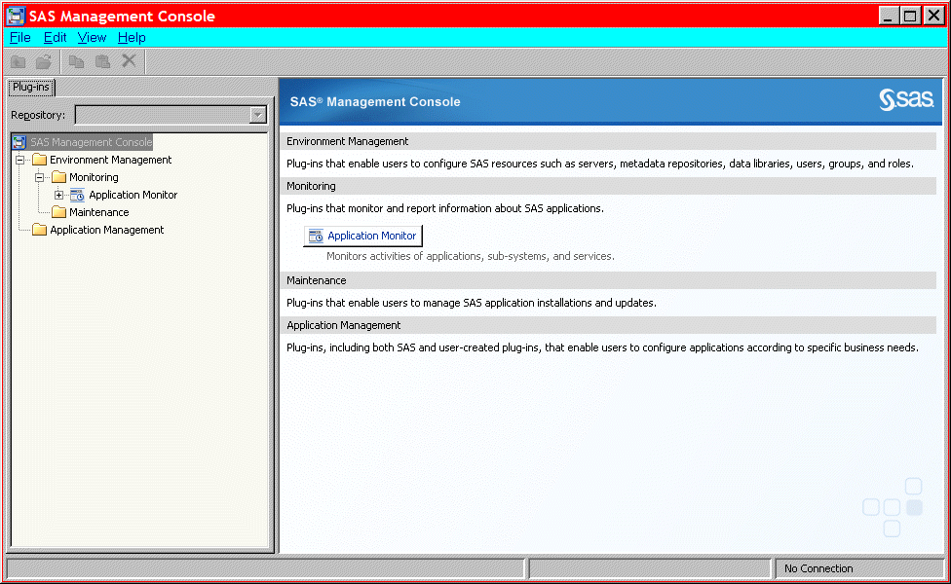
Display 1. Caption for Sample Display
This is a continuation of the body of the paper, after a screen shot has been included. This paragraph uses the PaperBody style.

Fourth Tertiary Level Subtopic for Second Main Topic
This is another third level subtopic of the main topic. This paragraph uses the PaperBody style.
If output is needed, then there should be a link to the output and a description of the output should be below the output itself. Note that the caption should be in sentence case as illustrated. Output 1 shows an example of how to present output.
CREATE TABLE ALLACCTX(SourceSystem varchar(4),
cctnum numeric(18,5) CONSTRAINT "ALLACCT_PK" PRIMARY KEY,
ccttype numeric(18,5),balance numeric(18,5),clientid numeric(18,5),
losedate date,opendate date,primary_cd numeric(18,5),status varchar(1))

Output 1. Caption for Sample Output
This is a continuation of the body of the paper, after an output has been included. This paragraph uses the PaperBody style.

Conclusion
This should be a brief recap of what the paper is about and how it could possibly benefit the user. This sample paper was created to illustrate the different concepts of topics and subtopics and how lists should be incorporated. It also illustrated how to incorporate code and other objects. This paragraph uses the PaperBody style.

References
This section is to list all reference material that was used in the development of the paper. Books, journal articles, articles in a conference proceeding and websites should be cited here if they were used as a source. For proper citation refer to the actual MWSUG Paper Template. This paragraph uses the PaperBody style.

Acknowledgments
This is the text for the acknowledgments. If anyone that has provided support during the development of the paper that the author wishes to acknowledge should be included in this section. This paragraph uses the PaperBody style.

Recommended Reading
- Book 1
- Book 2

Contact Information
Your comments and questions are valued and encouraged. Contact the author at:
Author 1 name
ABC Corporation
123-456-7890
author1name@abccorp.com
abccorp.com

Author 2 name
DEF Corporation
234-567-8901
Author2name@defcorp.com
defcorp.com

SAS and all other SAS Institute Inc. product or service names are registered trademarks or trademarks of SAS Institute Inc. in the USA and other countries. ® indicates USA registration.
Other brand and product names are trademarks of their respective companies.

